**Smart public restroom**

**phase-4**

The smart public restroom is gives the real time data in the smart app. Which can be accessed by the android apk.

First the app is build in the MIT app inventor so make sure that the required things like (image, layout, button,mqqt file).

First set the screen size and make the horizontal and vertical layout of the insertion button and images.

Then use the required image and layout text with required text used to click and show the data and represent the component using image.

The usage in my app is based on my simulation so the basic of two components pir sensor to detect motion and ultra sonic sensor to detect the distance.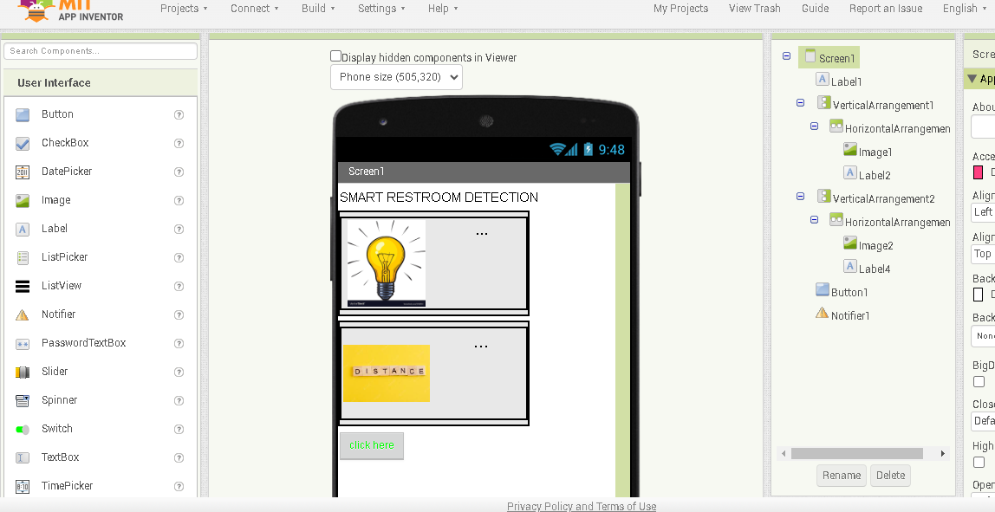

So if we click the button we can know the data of the motion detection and distance in usage of the smart restroom. The designer app is then the layot and the processing input are given correctly in design.

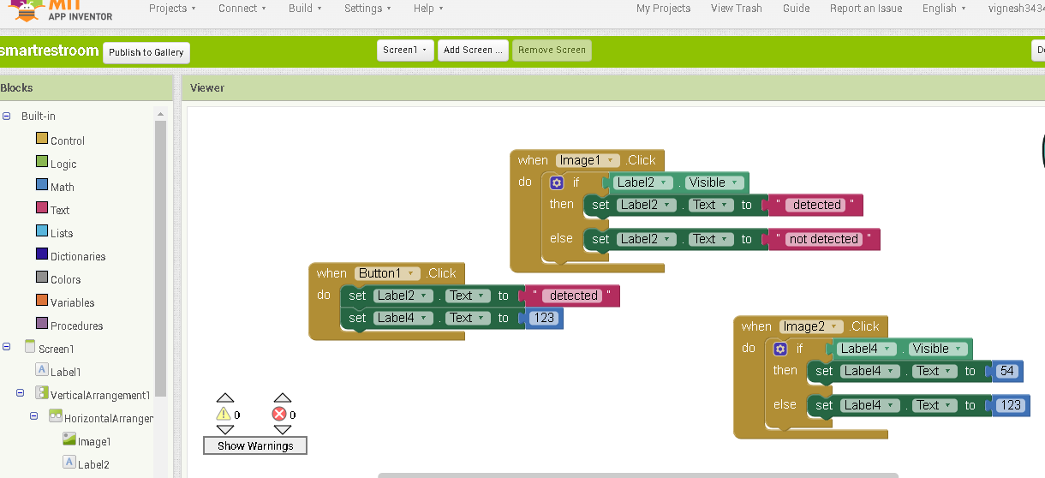

The blocks are like coding we have to give the proper function in the blocks to identify the layout image insertion and buttons .we have to give the data for the first image and second image and click button what to do? And the give the information about the data in the app.

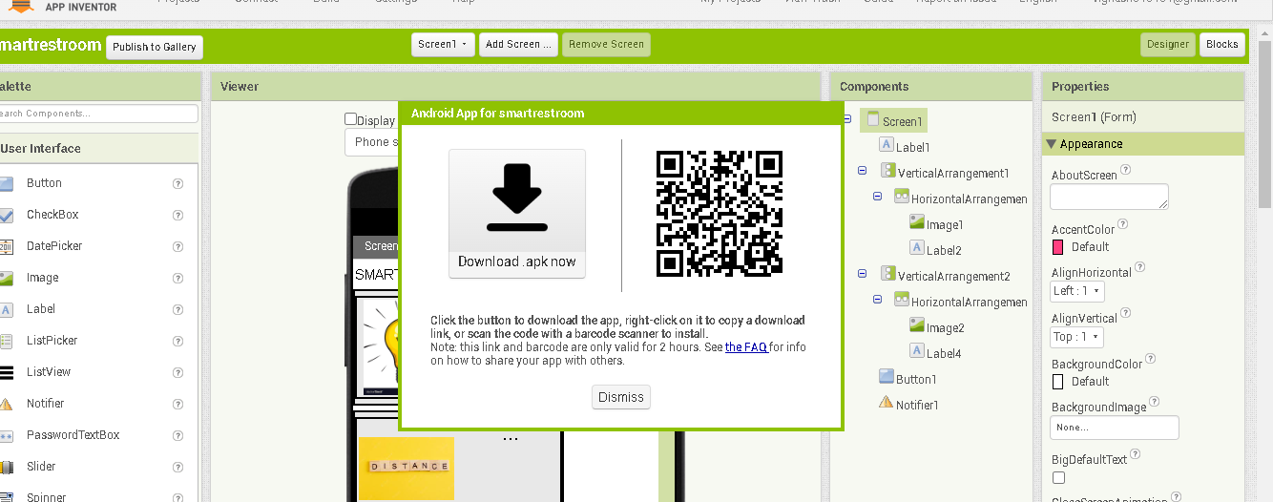

After completing the basic information details and getting the work done and download the mqqt extension download the zip file and extract the file and upload in the base apk.

Then build the app and the QR and the download dialog box will appear after the compiling the apk.

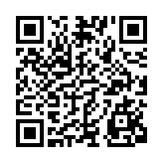Download and the check the apk.it shows the real time usage in the smart restroom.

The QRis given in the above for apk.